**2018 Spring Final report**

**Group #3 Mahshid Khodadad (20140942)**

In group 3 I was in LabVIEW team which handles the Control System for our car.Our task was to recieve data from the temperature sensors, controlling the mechanum wheels and also translate data from ROS and Open CV.

We used TCP/IP communication for communication between myRIO and NucPC.

**Progress reports**

**Week1~7 report**

**Assignment #1 (Due: March 16)**

1. Finish Launch myRIO example (Blink LEDs, measure accelerometer data example)

**Completed**

1. Finish myRIO configuration. (setting name, wireless connection) (Files attached)

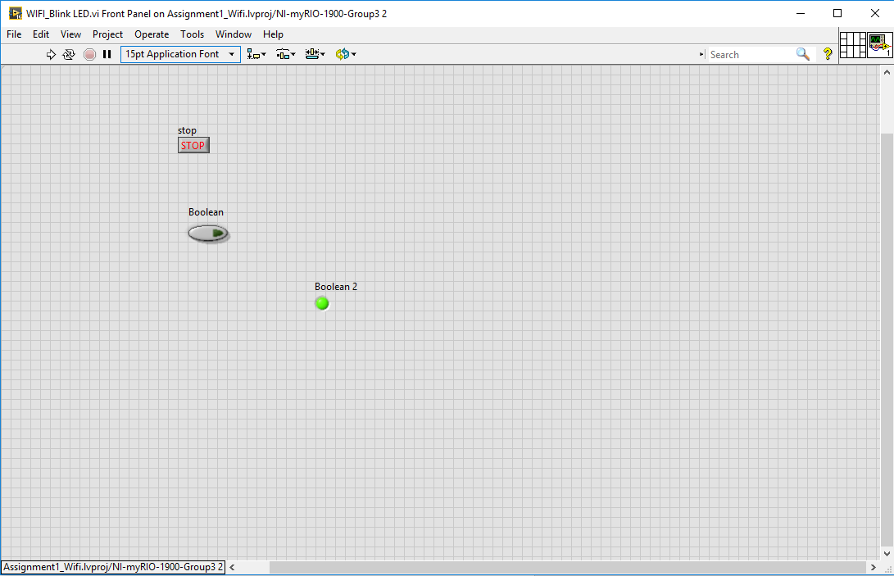

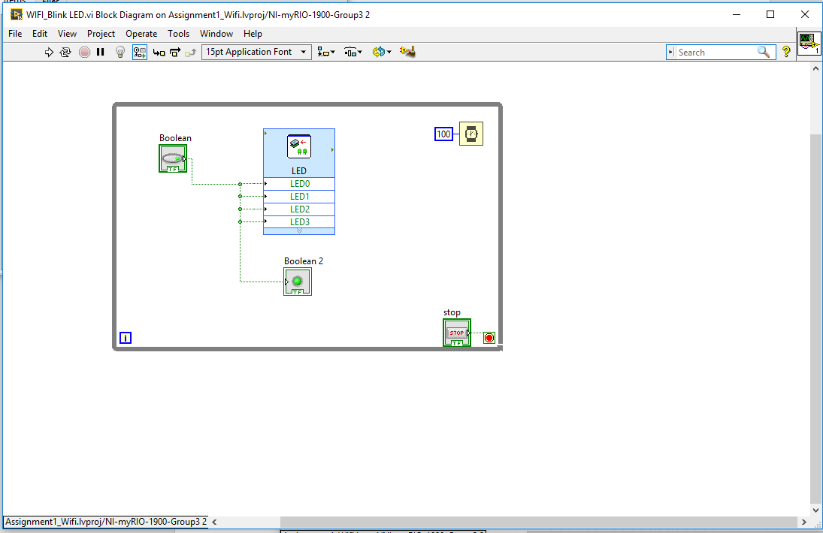

**Assignment #2 Due: March 22)**

1. Blink LED 1~4 in different time interval   
   (ex, LED1 : blink every 1s, LED2 : blink every 500ms, and so on…)

(**Finished)** Code submitted

1. Make LED 1~4 blink in order (LED1->LED2->LED3->LED4->LED1…)

(**Finished)** Code submitted

1. Make following system  
   3)-1. Measure accelerometer of myRIO and show the data on graph.

(**Some snapshots are attached)**

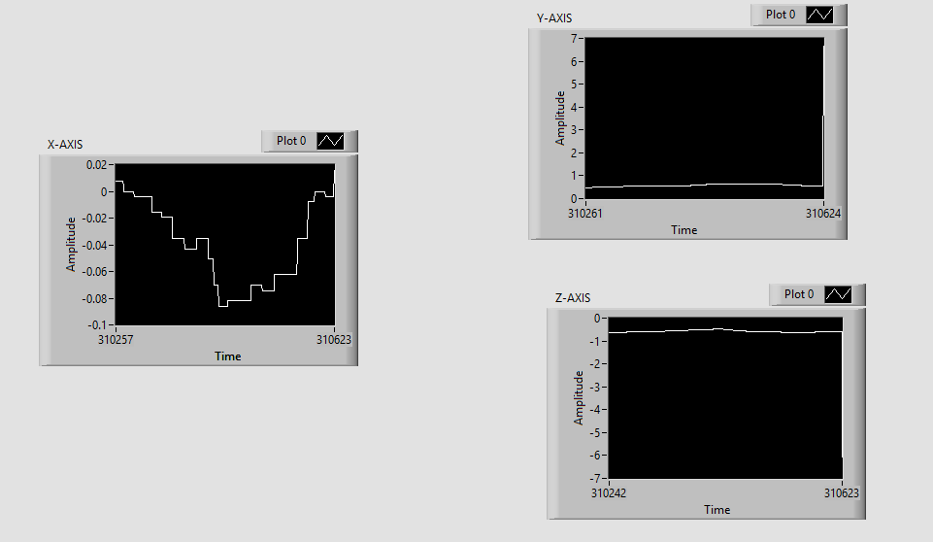

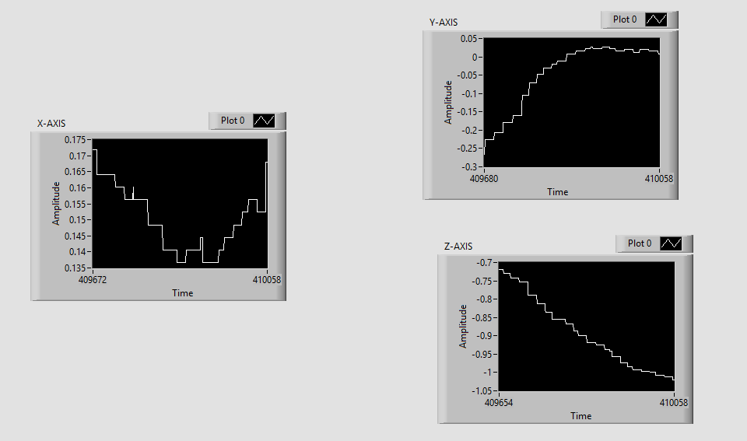

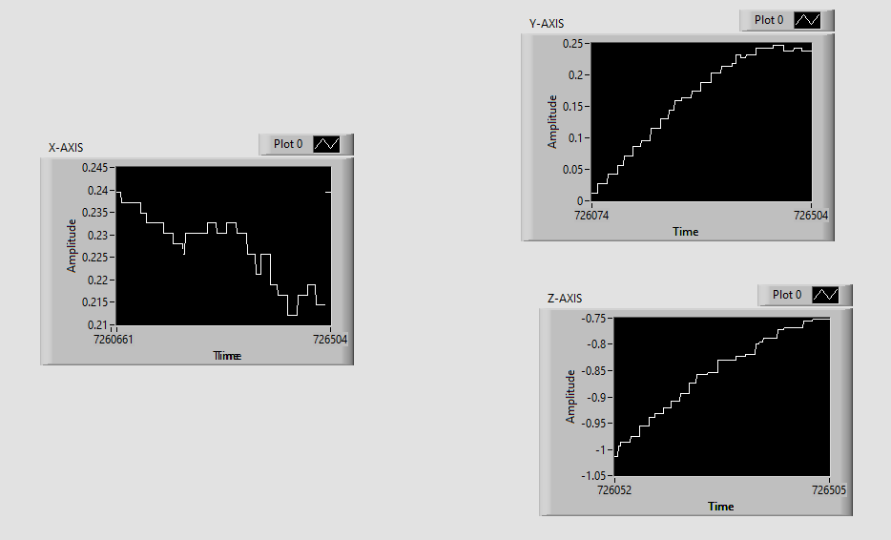

3)-3. If acceleration of myRIO is higher than typical threshold, turn on LED1.

**Finished: Code submitted**

**Assignment #3 Due: April 2)**

0)-1. Measure temperature and show the data on graph.

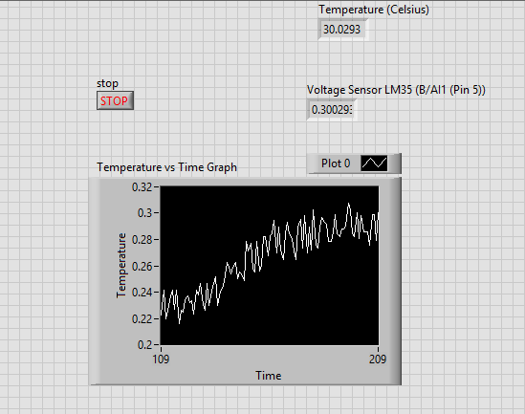  
0)-2. If temperature is higher than typical threshold, turn on LED2.

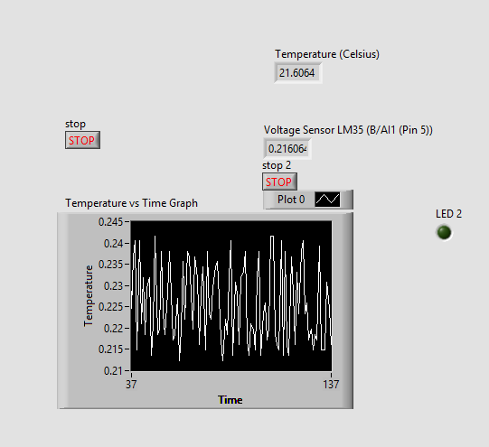

1. Following DXL example and TCP/IP example(course material p.65~p.82)

**Finished example**

Assignment #3

Make following program   
**[Control DXL which connect to myRIO using PC (TCP/IP)]**

**Control DYNAMIXEL motor speed and angle (position) using LabVIEW and myRIO:**We were able to control the speed and position of motor using LabVIEW and the keyboard.

**2)-1 Choose mode(wheel mode, position mode) some typical command from PC.  
2)-2 In wheel mode, change speed of DXL using PC command.**

For this part of assignment we were able to make the codes for four different motors using the code that was given to us for one motor and change the speed for each separately. we realized that there is only positive values possible for the speed and we cannot enter negative amount as speed value **2)-3 In position mode, change angle of DXL using PC command.**

For this part of assignment also we were able to make the codes for changing the position of four motors also .for the position we are able to enter positive and negative values since they are more like spinning angle .

1. **Control DYNAMIXEL motors and car direction using XBOX:**

During the last weeks we managed to control the motors with Xbox controller.to do so we made a local variables of arrays of the keys for the motors and we tries to connect the local variables to each of motors separately .and while getting the signal from the Xbox controller ,we were able to control the motors one by one separately.

**Week 8 report**

During this week we tried to get rid of the delay for LabVIEW. Firstly we tried to Synchronize the loops using timing and by calculating the time duration of the one loop and give the shortest loop a delay .But finding the duration for each loop and synchronizing them to the last ms is not an optimal option so we tried to just merge the loops to one loop instead so all the functions will happen in just one loop.Now instead of having different loop for motors and keys ,we only have one loop which does all the job and controls everything.

**Week 9~10 Report**

After removing the delay of the labview codes we tried to move the the codes to the myRio.Inorder to do so we set up the startup on the myRio and moved the codes.

We also tried to make delay time for the LabVIEW codes so the car can move in one direction for 10 seconds . but since we had a hard time tracking the code changes we decided to change the Xbox variables into the floating point numbers.

Also during the last week we tried to remove the box controller codes and make the codes simpler. After doing so we were able to simplify the code from array of Xbox numbers to simple two variables: cases (dealing with directions) and delay (dealing with the amount of time the car follows a direction).

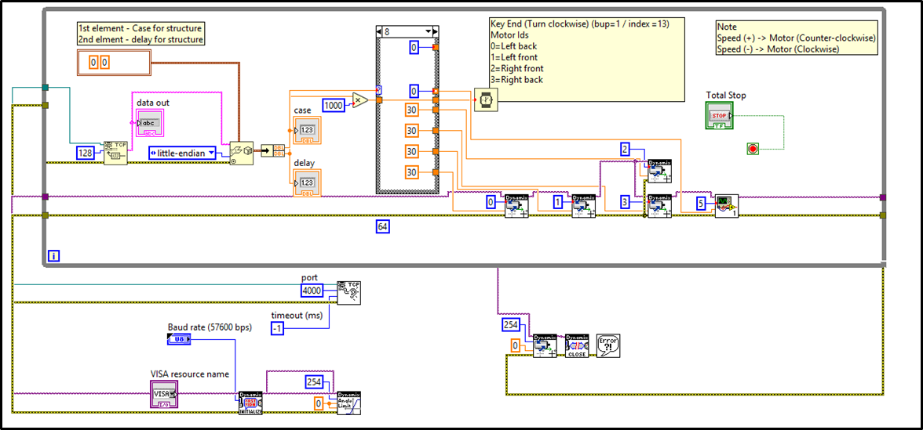

In The above figure we can see the code we made to make debugging and modifying simpler. It features 4 different wheels for dynamixels and other dynamixel as actuator.

Lastly we added the AX-18 Dynamixel actuator for the gripping mechanism of the robot.Since the controlling is different than the mototrs used for wheels we made another program which you can see in the figure below.in this program we can adjust the speed and conversion ratio.

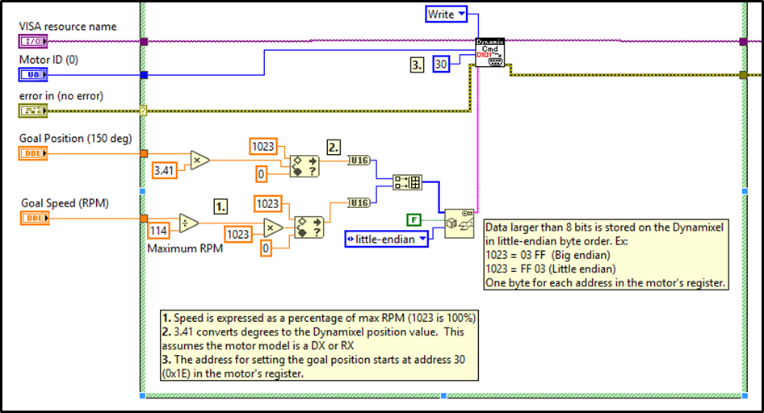

**Week 10~**

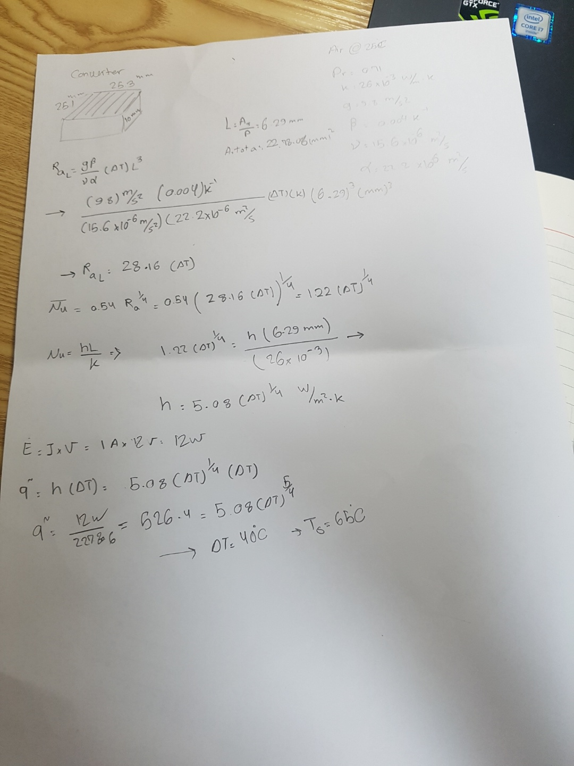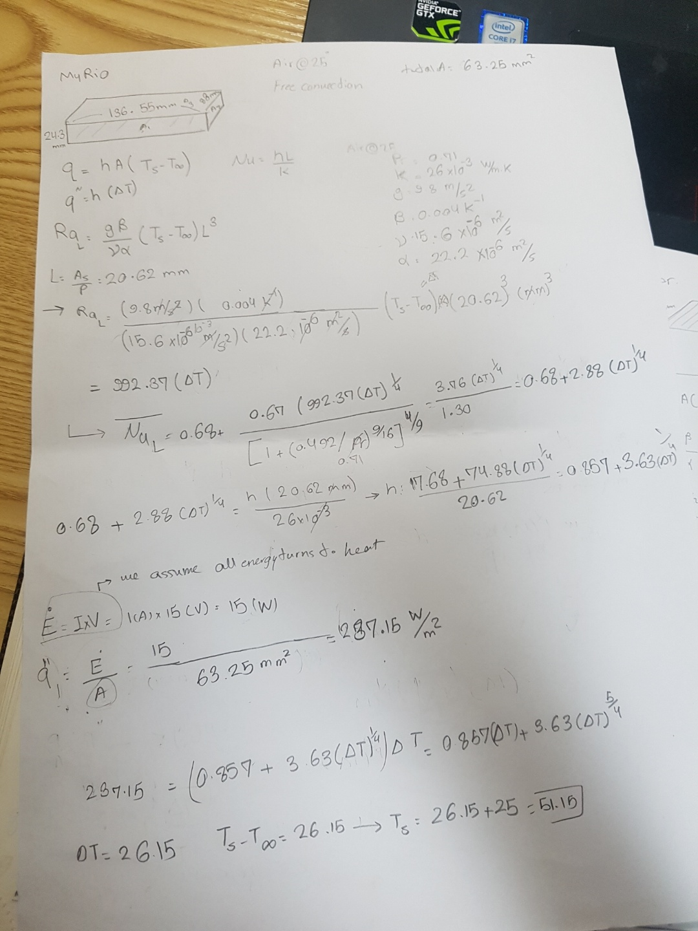during the final week of project ,I was incharge of analyzing heat transfer of different parts and making the calculations.To do so after meeting with TA ,I firstly took the photos with IR camera of the parts and through heat transfer analysis and rules i calculated the amount of heat that can be dissipated from each parts and the compare with the tempreture measured by IR camera and then decide if we need any type of fin of fan to reduce the tempreture.this photos below are afew of analysis i did for heattrasfer

.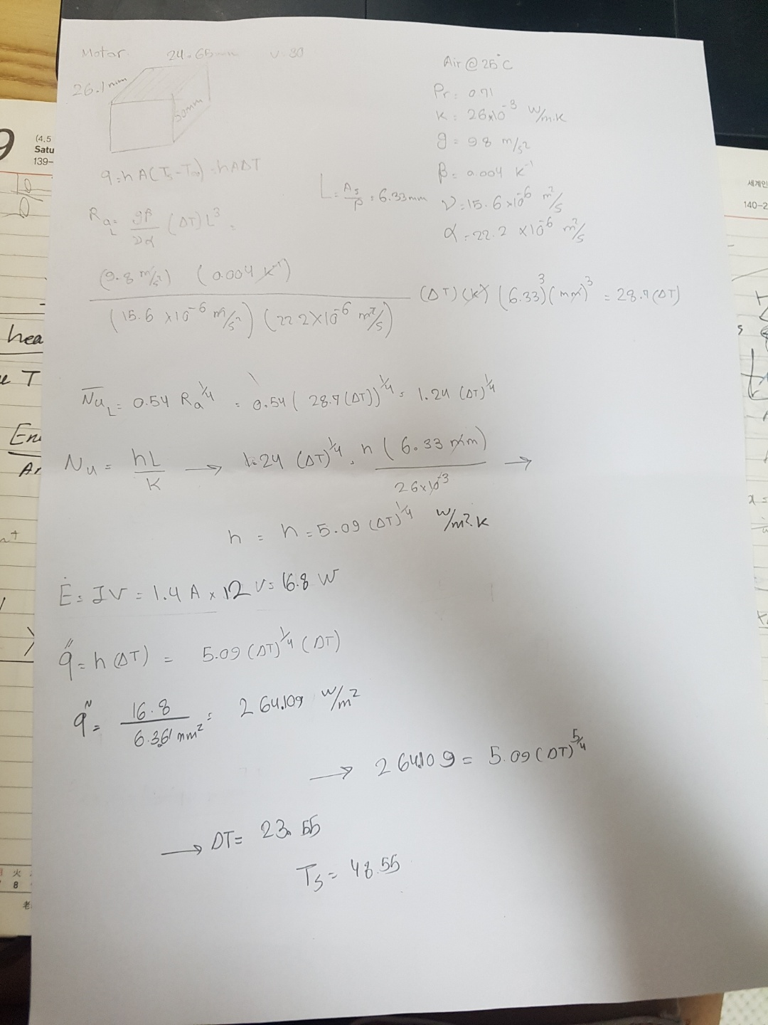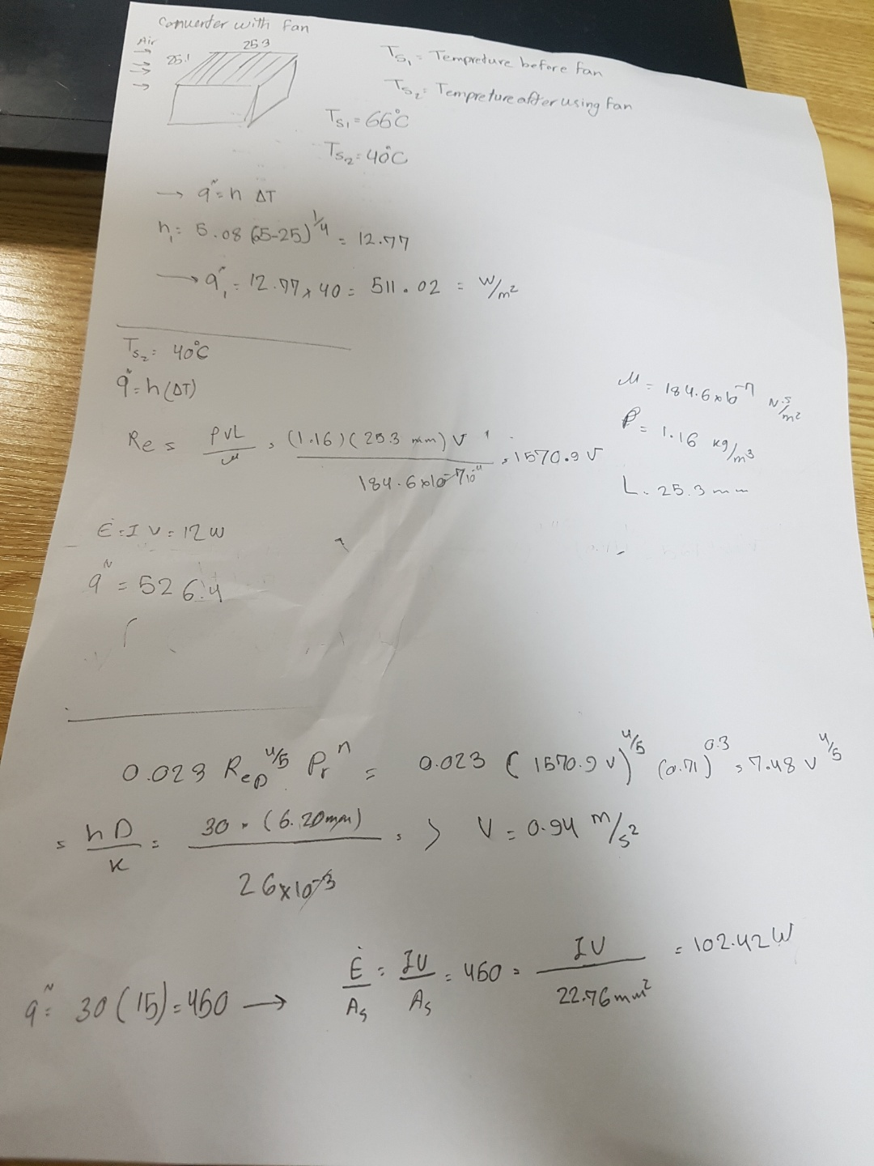

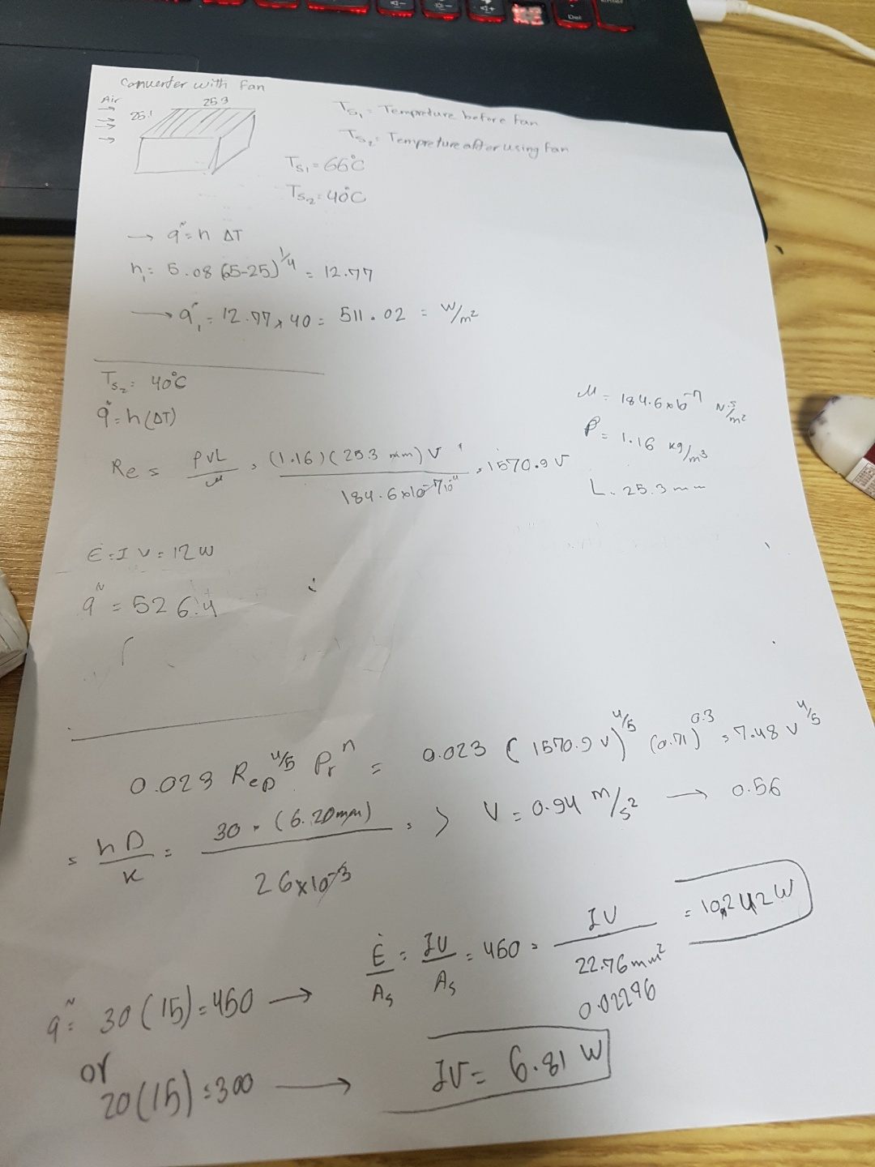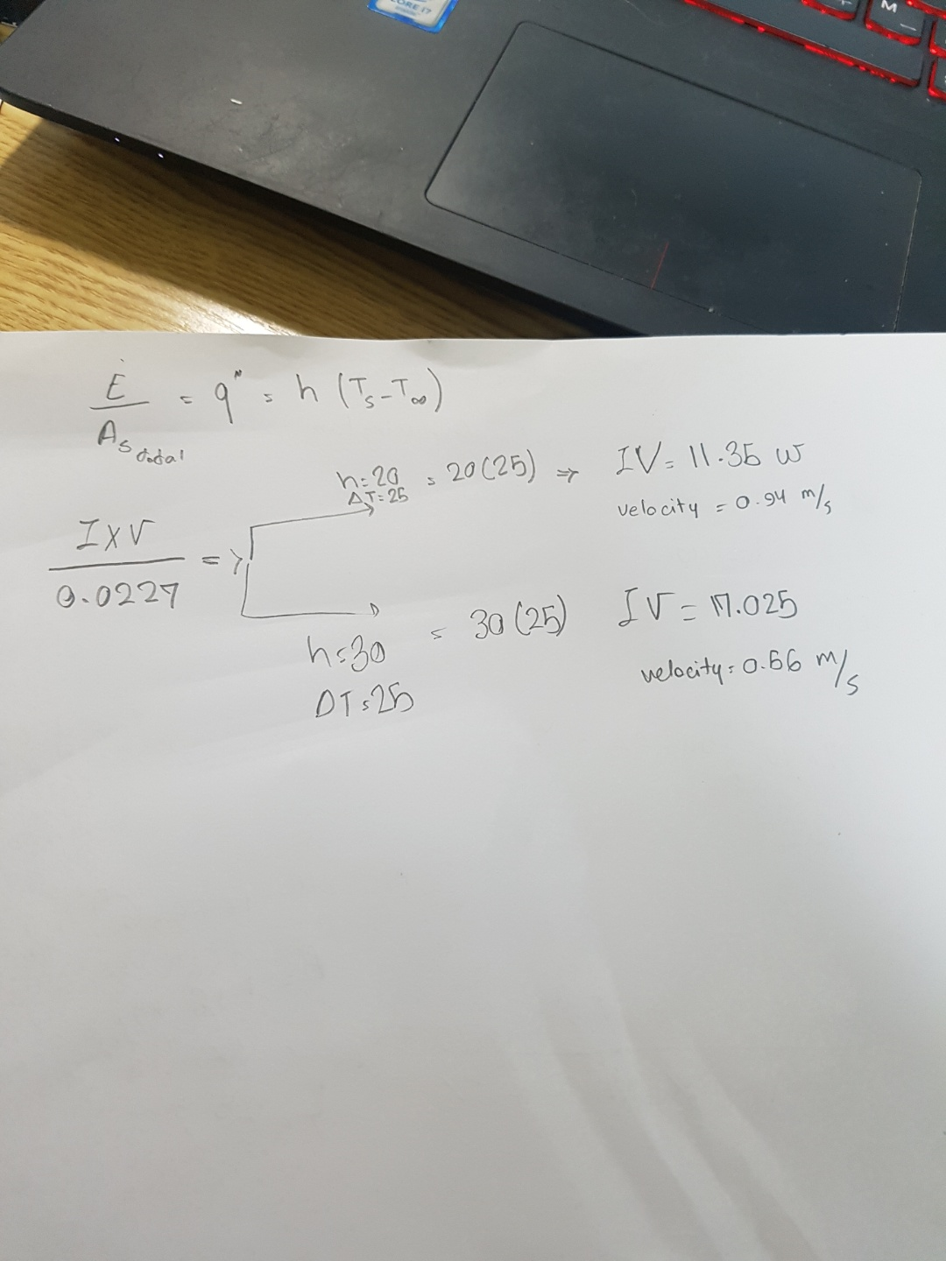

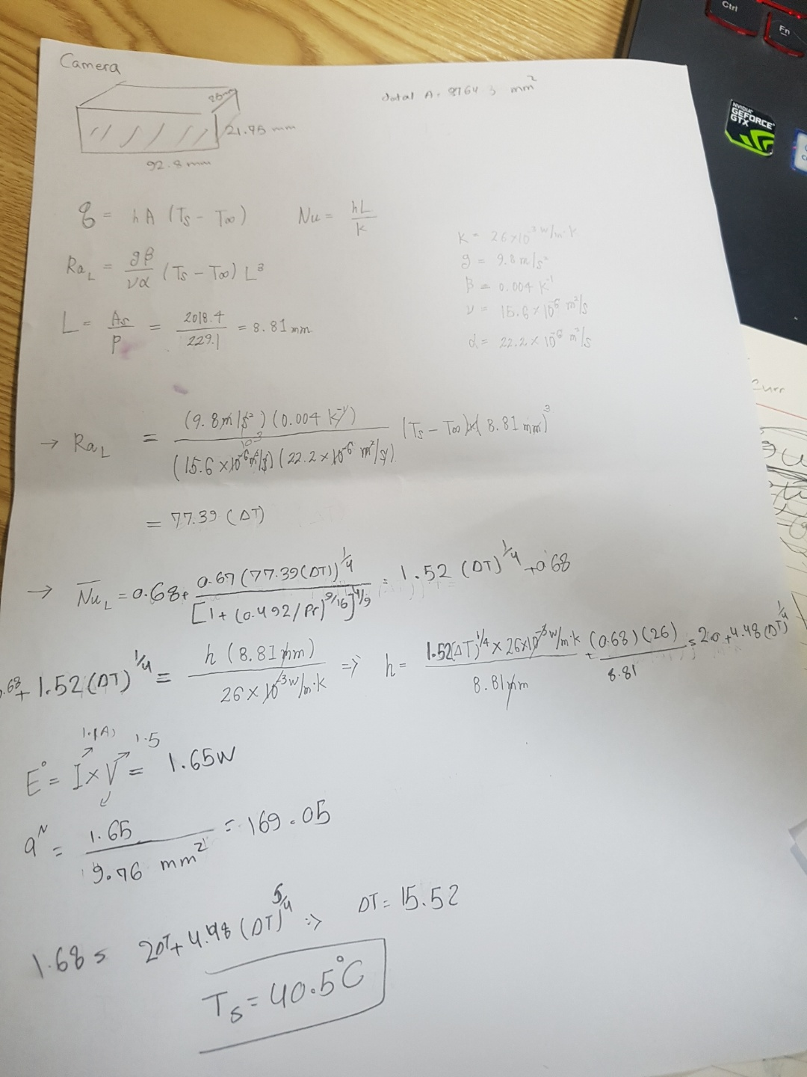

**Materials for meeting with professor**

every week on thursdays 4 PM we had meeting with professor .We got great comments abouut the designs ,progress ,analysis.Bellow is some comments we got about the presentation mterials and designs.

-just put the whole picture of the system and stretch out lines that can explain each parts. that way we can explain about all the smaller systems in one slide.

-opencv part - put raw image or take another picture without hand shade

-we should take out the thermal grease

-he's also not sure that if modularity can be a merit in creativity -> what about the other groups??

-based on our several trial and error, we found the need for modularity. Also we thought about the capstone design 2, which we might possibly have the need to change the picking part, suspension, wheels, and more. so we made the whole system very modular, and we found it very useful during the whole time, because we could change small parts every time when we needed too.

-we need a new figure for the vibration(prof says). search in google about fft~

-dont forget to plot in logscale(both axis)

-what about cutting the graph and show the data from the point where the large amplification occurs in the vibration

-difference -> "summarizing the system" and then put the details that can show the uniqueness of our group

**extra materials for meetings with team members**

during one semester all members worked extemely hard and did their best to make this project happen.Most of the times we had long meetings even until morning and did our best for each part the videos and photos below are an overview of the whole project and our meetings.

